Created a Document (AKS10) and set Effective Date to 2/19/2019
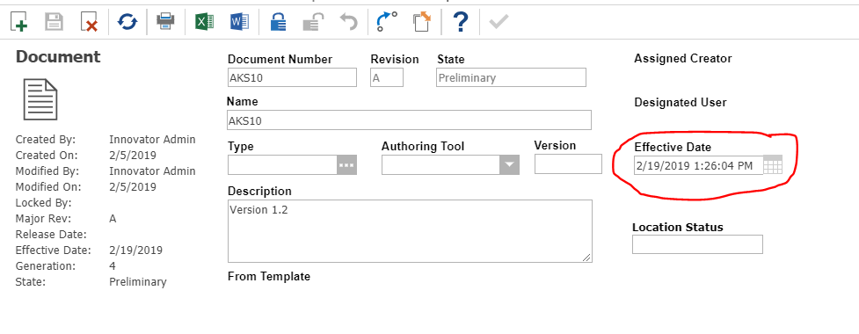
I have another Document (AKS11) where I have not set Effective Date
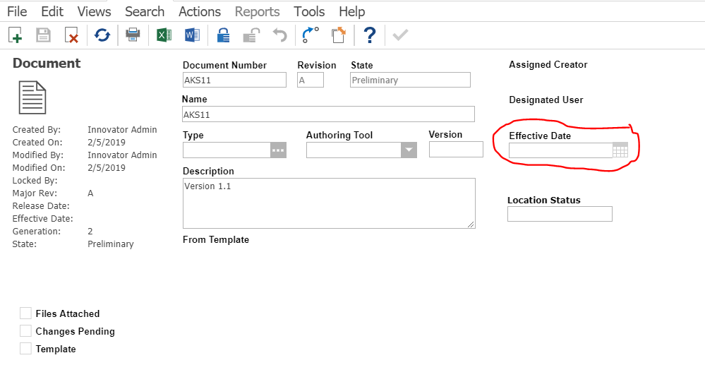

Now when I search for Document in main search window with Effective Date as Today (2/5/2019), I don’t see either documents (AKS10 or AKS11). My expectation was that both should show up since AKS10 is Effective till 2/19/2019 and AKS11 doesn’t have any end date for Effective Date field. Shouldn’t the search should return all the documents where current date =< the effective date? If that is not the behavior then can you elaborate what is expected behavior for ‘Effective’ search condition?
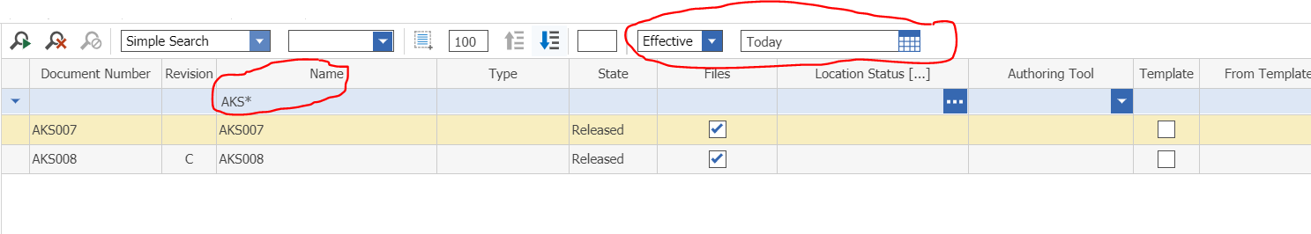

When I search for ‘Current’ then system shows me both of my Documents
