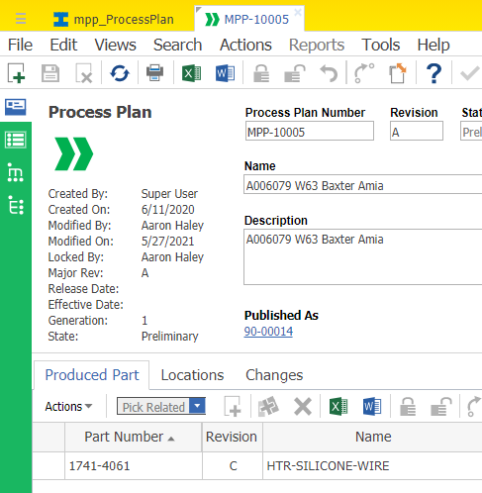
MPP Form with the Produced Part tab. Want to add the highlighted Part Number as a foreign data source.

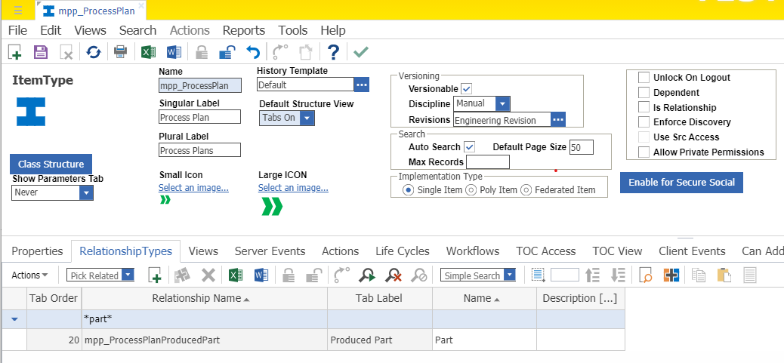
MPP Item Type with the Produced Part Relationship Type.

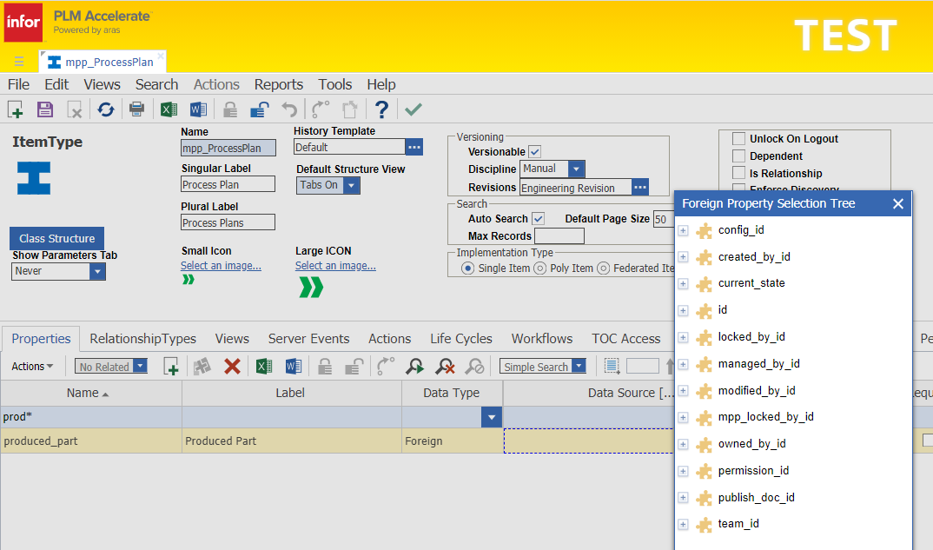
In the Foreign Property Selection Tree I do not see anything about the Produced Part that would allow me to display/search the above Part Number on the MPP grid.

